How visible and readable do you feel each of the following are on the Application - [Link](https://app.uizard.io/p/d82ceb8b)

Ranking: 9 / 10



Comments: Very good, could date maybe be a darker text

Ranking: 2 / 10

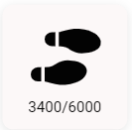

Comments: Found the text hard to see compared to the black icon

Ranking: 6 / 10



Comments: Took a minute to figure out what icon meant, but easy to follow once I did

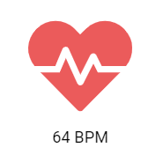

Ranking: 10 / 10

Comments: Colour and Icon used make it easy

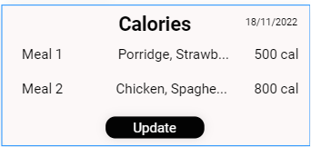

Ranking: 10 / 10

Comments: I think this is very important, especially if my trainer can also see a breakdown of what im eating

Ranking: 10 / 10



Comments: Again, very important as long as it is going back to my trainer aswell